**Network Design Proposal for Apollo Business Consulting**

**Prepared for Simon Galton**

**COMP 10019**

**Fall 2024**

**Table of Contents**

|  |  |  |
| --- | --- | --- |
| Section |  | Page Number |
| Introduction | . . . . . . . . . . . . . . . . . . . . | 3 |
| Executive Summary | . . . . . . . . . . . . . . . . . . . . | 4 |
| Business Profile | . . . . . . . . . . . . . . . . . . . . | 5 |
| Logical Network | . . . . . . . . . . . . . . . . . . . . | 6 - 10 |
| Physical Network | . . . . . . . . . . . . . . . . . . . . | 11 - 16 |
| Cabling | . . . . . . . . . . . . . . . . . . . . | 17 - 26 |
| Hardware | . . . . . . . . . . . . . . . . . . . . | 27 - |
| Wireless Option | . . . . . . . . . . . . . . . . . . . . | 9 |
| Cost Estimates | . . . . . . . . . . . . . . . . . . . . | 10 |
| Conclusions | . . . . . . . . . . . . . . . . . . . . | 11 |
| Appendix A:  Current Floorplans | . . . . . . . . . . . . . . . . . . . . | 12 |
| Appendix B: Subnetting | . . . . . . . . . . . . . . . . . . . . | 8 |

**Introduction**

The purpose of this document is to provide a thorough overview of SHANA Networks' proposed 3-tier network design for Apollo Business Consulting's new 5 floor campus.

At every stage of our process, we have made design decisions with your future in mind. In the dialogue we've had with your representatives, and the supplementary research we've done into your enterprise, it has been made abundantly clear that our design needs to support the growth your company expects to see over the coming years. We at SHANA believe our design will provide you with a fast, robust, and scalable network that can act as a sturdy foundation the folks at Apollo Business Consulting can rely on for years to come.

This report will clarify the specifics of our design, rationalize those decisions in the context of your organization, and provide insight and analysis where appropriate. At a glance, this design will provide your campus with a suite of high-end Cisco switches including: 3x Catalyst 9300X, 8x CBS350-24FP-4X, 8x CBS350-48FP-4X, and 5x CBS350-8FP-E-2G. These switches will be interconnected by 345 meters of multi-mode fibre, and 13388 meters of Category 6 cabling all of which comply with TIA/EIA 568 standards.

We look forward to bringing this project to life and on behalf of the SHANA team:

*Thank you for the opportunity to provide this proposal.*

* Add blurb on firewall, wlc, and other misc hardware
* Intro will thank the business for the opportunity and acknowledge key points that influenced design decisions.
* Brief summary of topology, wide overview

**Executive Summary**

This report provides a thorough overview of the 3-tiered network SHANA networks is proposing for Apollo Business Consulting's new 5 floor campus.

This design makes use of high-end Cisco switches including the Cisco Catalyst 9300X for both the core and distribution layers as well as a suite of Cisco Business 350 series switches such as the CBS350-24FP-4X, and CBS350-48FP-4X which will provide access level connectivity. Additionally, our design will provide a set of Cisco CBS350-8FP-E-2G switches which will allow for the implementation of an AP array after a thorough site survey is conducted. This hardware will be connected vertically by a 345 meter multi-mode fibre backbone and distributed to your employee workstations via 13,388 meters of Category 6 cabling all of which comply with TIA/EIA 568 standards.

This design will provide all 311 employees of Apollo Business Consulting and its president each with a 1 Gigabit connection to this network with significant room for growth.

Our installation estimate will amount to a total of $XXX and our team has calculated a yearly upkeep of $XXX which includes any necessary service, maintenance, and upkeep.

* Need to finalize costs
* Add additional hardware specifics if intro is edited

**Business Profile**

Over its 15 year history, Apollo Business Consulting's commitment to corporate excellence has fuelled it's growth to an impressive 311 employees which span a hierarchy of 11 distinct departments.

This year marks a bold milestone for Apollo, as the company has opted to relocate their operations to a brand-new, cutting-edge 5 floor campus; citing a dedication to provide their staff with an environment that fosters collaboration and innovation. This move will provide Apollo with the opportunity to develop and deliver meaningful initiatives to the clients and communities that have come to rely on their services and will undoubtedly stoke the next 15 years of their growth.

At the heart of this operation is an impressive 311 employee workforce which is broken down into 11 major departments: HR, Finance, Sales and Marketing, Legal, IT, Security, Communications, Business Consultants, Client Management, Research and Analysis, and Project Management. Their staff attributes their success to the hierarchical structuring of these departments and the integration of its executive individuals into each of their respective departments where they work alongside their staff as a unified team.

To support this workforce and their clients, Apollo Business Consulting maintains a series of networked printers and VOIP phones as well as several on-site physical and virtual servers. These servers provide internal staff with e-mail and other office productivity services like file sharing, and collaborative task management. Additionally, these servers host numerous web-services which provide clients with access to real-time analytics, collaboration tools, and database services all through a convenient and modern dashboard interface. This modular implementation of virtualized servers provides Apollo with the flexibility to grow seamlessly with the demands of their clientele, and demonstrates Apollo’s continued dedication to innovation and productivity.

* acknowledge the business, it's growth etc
* share department breakdown and the services they use

**Proposed Logical Network Layout**

The following diagrams outline the proposed logical network for Apollo Business Consulting’s 5 story campus. For the sake of clarity, this design will be explained as a set of 4 logical sectors: C1, D1, D2, and W.

**Logical Overview**

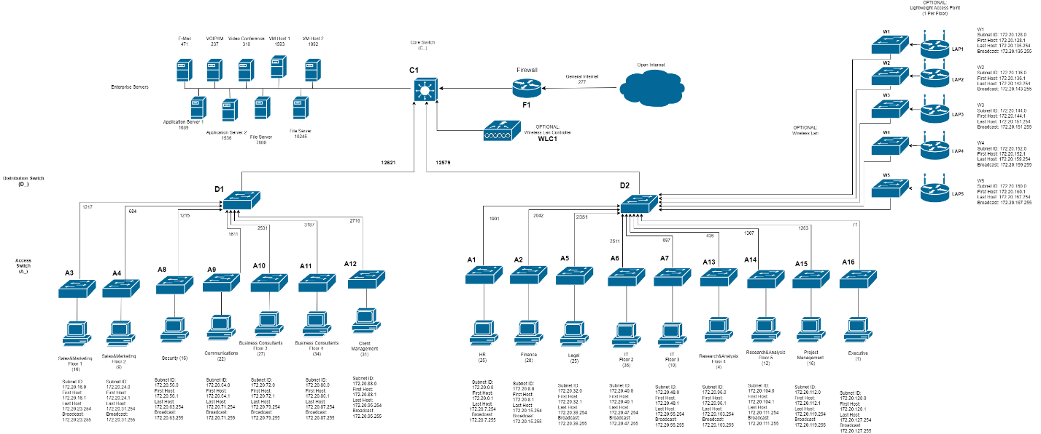

For each sector, a brief description of the hardware and its connections will be provided and will be detailed later in this document (see Hardware). Additionally, preliminary subnetting has been provided to help clarify how this network can be logically segmented (see Appendix B).

**C1 (Core)**

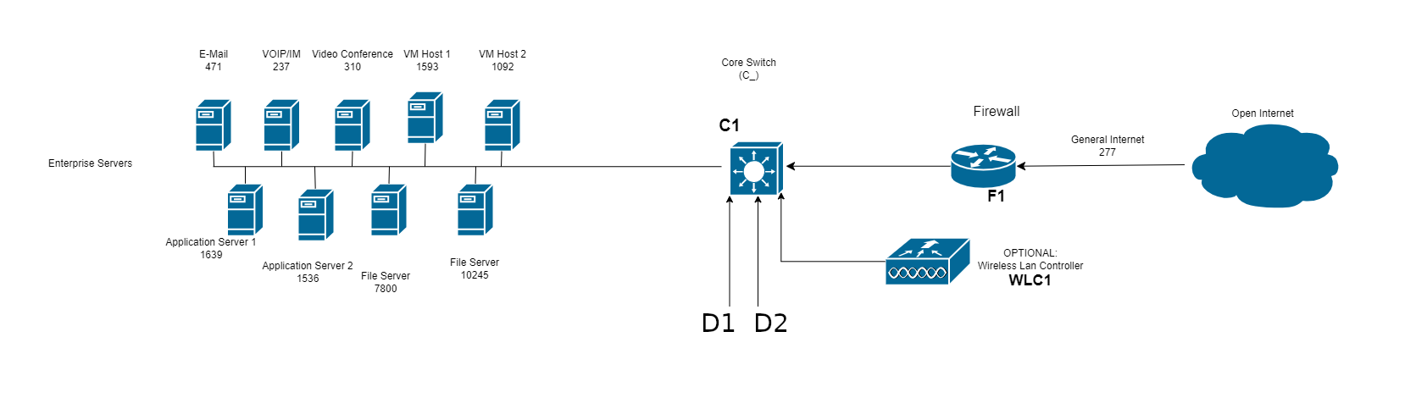

In our design, your Rogers Business Internet Connection is fed to a FirePOWER 3140 firewall which will protect your network from the open internet. From there, “C1” serves to represent your primary core switch. This Catalyst 9300X is where your enterprise servers will directly connect to the network and where a Catalyst 9800 WLC will be connected to control an array of access points we will detail later in this document. Both of the distribution tier switches we have provided will connect to C1 at this level.

**D1 (Distribution 1)**

Depicted in this diagram a switch we refer to as “D1”, another Catalyst 9300X which will serve as the first in a set of 2 distribution switches for your network. 7 access level switches are connected to “D1” and these switches will provide direct connections for your employees to access the network. Notably, each of the depicted departments are isolated on individual switches which will provide added network security for your daily operations.

**D2 (Distribution 2)**

Like “C1” and “D1”, “D2” is also a Catalyst 9300X and will serve a connection to 9 more access level switches. As was the case with “D1”, each department is isolated on their own access switch for network security. Notably, the “D2” trunk of our topology includes another 5 switches which serve a connection to a set of access points we have included in this design. See sector “W” for details.

**W (Wireless Foundation)**

Pending a formal site survey, our design provides 5x CBS350-8FP-E-2G switches and 5x C9120AXI-EWC-A Access Points which will each serve an individual floor of your campus and is provided its uplink by the “D2” trunk.

This configuration, and the aforementioned site-survey will be detailed in the “Wireless” component of this report.

**Proposed Physical Network Layout**

This design makes use of a first-floor entrance facility (EF) which houses the demarcation point provided by Rogers. This demarcation point will be extended through conduit directly up to the second floor which will provide a short and efficient channel between the the EF and the primary equipment room (ER).

Although the EF occupies some portion of the first-floor finance office and the ER occupies the majority of the second floor East IT office, we have calculated the space the EF and ER will occupy and are confident the space will NOT displace any employees as you currently plan to have them situated.

Specifically, the ER will occupy 144m2 which will leave 115m2 for the staff that will work there. Given the 10 employees and an average cubicle size of around ~6m2 this will leave roughly 55m2 for walking and airflow which we anticipate will be more than sufficient. The ER itself will contain the primary core switch (C1), firewall (f1), WLC, and all of your enterprise servers and virtual hosts.

From the ER, a backbone of multimode fiber is provided to the telephone rooms (TR) on the second floor. These TR’s each will house a distribution switch (D1 and D2 respectively) and several access switches. From these distribution switches, a vertical backbone of multimode fibre provides direct connection to access level switches on each floor, all housed in the TR’s that alight vertically as depicted in the following diagrams. These access level switches will serve connection each of your 311 employees and your president via Category 6 cable. This cabling is omitted from these diagrams for clarity but are detailed in the ”Cabling” section of this document.

The following diagrams outline the proposed physical network for Apollo Business Consulting’s 5 story campus. A legend has been provided along side each floorplan for your convenience and clarity

All devices are named and mapped on a floor by floor basis as per the attached table. And detailed lists of this hardware will be provided in the “Hardware” section of this document.

**First Floor**

**Second Floor**

**Third Floor**

**Fourth Floor**

**Fifth Floor**

**Cabling**

Our plan is to install a demarcation point extension from the first floor entrance facility to our equipment room via plenum rated multi-mode fiber cable directly into our firewall. From here, the same plenum fiber connects to our core switch in our equipment room where 2 fiber trunks span to our distribution switches separately located in telecommunication rooms TR2A and TR2B. These distribution switches connect with fiber to each of our access switches vertically through our TRs and horizontally to the appropriate switch according to how our network bandwidth is load balanced.

Horizontal cabling is organized with cable trays attached to existing building infrastructure with threaded rods, allowing plenty of room within plenum space for cable expansion and providing easy cable management. Our access switches use Category 6 plenum rated cables to reach client work areas and access jacks within each office, all of which comply with TIA/EIA 568 standards. These jacks connect to Category 6 work area cables for each office, providing all employees with a reliable, fast network connection. Additionally, plenum rated fiber cables provide network redundancy between telecommunication rooms on each floor, and patch panels within network device racks allow fast accessibility to every port on every switch.

**Total Cable Lengths**

|  |  |  |  |
| --- | --- | --- | --- |
| Placement | Type | Total Length | Cost Estimate |
| Work Area | Category 6 | 1691 meters | ~$4,633.34 |
| Horizontal | Category 6 | 11792 meters | ~$124,363.35 |
| Backbone | Multi-mode Fiber | 345 meters | ~$3,057.60 |
| TR Patch Cables | Cat6/Fiber | 163 meters | ~$1,040.45 |

**Work Area Cable**

|  |  |  |  |
| --- | --- | --- | --- |
| Cable | Description | Amount | Image |
| RJ45 Cat6 UTP Ultra-Thin Patch Cable - Premium Fluke® Patch Cable Certified - CMR Riser Rated | Category 6 cables of various lengths per office provide client node access within each office | 311 cables between 1-13 meters:  ~$2.74/meter |  |

**Note**: All measurements are in **METERS**, please disregard the following table headers showing feet.

**Floor 1 - Work Area (Calculations in Meters)**

**Floor 2 - Work Area (Calculations in Meters)**

**Floor 3 - Work Area (Calculations in Meters)**

**Floor 4 - Work Area (Calculations in Meters)**

**Floor 5 - Work Area (Calculations in Meters)**

**Horizontal Cabling**

|  |  |  |  |
| --- | --- | --- | --- |
| Cable | Description | Amount | Image |
| 304.8 meters 4 Pair CAT6 Solid U/UTP 550Mhz 23AWG CMP Plenum Bulk Cable | Plenum rated Category 6 cabling is bought in bulk to cover the 11697 meters required for the entire company | 39 boxes @ $362.50/each |  |
| Middle Atlantic 6’ Long 5/8” Threaded Rod | Threaded rods connect our cable trays to our ceiling cable runs within hallways to our work areas | ~400 @ $48.99/each |  |
| Tripp Lite Rack Enclosure Cabinet 10ft Roof Cable Manager Ladder 10' - rack roof mount cable manager ladder | Cable trays provide cable organization and easy management within the office’s hallways and infrastructure | ~400 @ $225/each |  |
| OM4 Multimode 50 Micron Indoor (Corning ClearCurve) - OFNP Plenum Fiber Bulk Cable - 12-Strand | Plenum rated fiber cable connects between TR rooms on each floor providing redundant connections between both distribution trunks | 95 meters @ $6.63/meter |  |

**Floor 1 - Horizontal (Calculations in Meters)**

**Floor 2 - Horizontal (Calculations in Meters)**

**Floor 3 - Horizontal (Calculations in Meters)**

**Floor 3/4 - Horizontal (Calculations in Meters)**

**Floor 4/5 - Horizontal (Calculations in Meters)**

**Note:** An additional 95 meters of multi-mode fibre can connect between TR1-5A and TR1-5B on their respective floors providing redundancy between distribution branches.

**Backbone Cabling**

|  |  |  |  |
| --- | --- | --- | --- |
| Cable | Description | Amount | Image |
| OM4 Multimode 50 Micron Indoor (Corning ClearCurve) - OFNP Plenum Fiber Bulk Cable - 24-Strand | Plenum rated fiber cable bought in bulk to connect from Demarcation to F1 to C1 with D1 and D2 | 74 meters @ $12.73/meter |  |
| OM4 Multimode 50 Micron Indoor (Corning ClearCurve) - OFNP Plenum Fiber Bulk Cable - 12-Strand | Plenum rated fiber cable bought in bulk to connect each access switch with its distribution switch | 271 meters @ $6.63/meter |  |
| 3m LC/PC 12-Fiber OM4 Multimode Simplex 50 micron - 900um Pigtail - Color Coded | Spliced pigtails allow our fiber cable to connect with our fiber patch panels and backbone switches | 7 @ $45.55/each |  |

**Note:** Distribution switches located in TR2A and TR2B to save on fibre cabling costs and increase security

**Telecommunication Rooms Patch Cabling**

|  |  |  |  |
| --- | --- | --- | --- |
| Cable | Description | Amount | Image |
| RJ45 Cat6 UTP Ultra-Thin Patch Cable - Premium Fluke® Patch Cable Certified - CMR Riser Rated | Category 6 cables for connecting switches with patch panels within our racks – 6 inches | 156 @ $2.10/each |  |
| RJ45 Cat6 UTP Ultra-Thin Patch Cable - Premium Fluke® Patch Cable Certified - CMR Riser Rated | Category 6 cables for connecting switches with patch panels within our racks – 1 foot | 155 @ $2.21/each |  |
| OM4 Multimode Duplex LC/LC 50 Micron - Fiber Optic Patch Cable - 2mm Jacket - LSZH/OFNR - 0.5m | Fiber cables for SFP+ connects between switches | 46 @ $8.05/each |  |

**Hardware**

Every tier of this network design makes use of high-end Cisco switches. Each device was carefully selected based on available features and specific models and sizes were selected within the context of the growth Apollo Business Consulting expects to see over the next several years.

Firewall

Cisco FirePOWER 3140 Next Gen Firewall (FPR3140-NGFW-K9)

Core

Cisco Catalyst 9300X (C9300X2-24Y)

**Proposed Wireless Configuration**

The xxxxx

* Would need to perform a Wireless Site Survey to determine the most efficient location for our APs.
* This section provides a general overview of how we would implement an array of APs to provide an ESS to the building.
* Reference Wireless Site Survey lecture (wireless class) heavily

**Cost Estimates**

The xxxxx

* Provide thorough cost analysis
* Include table

**Conclusions**

The xxxxx

* Any additional remarks, contexts, rationale can go here
* Conclusions, thanks etc.

**Appendix A – Current Office Layout**

The unoccupied offices are currently configured as follows:

* Include original svg files for reference

**Appendix B – Subnetting**

The unoccupied offices are currently configured as follows:

* Any other documentation, imagery, diagrams, or supporting material can go here in subsequent apendices